https://expertphotography.com/gimp-vs-photoshop/:

GIMP vs Photoshop – Which is Best? (expertphotography.com)
 | by Craig Hull
Photoshop is the most known photographic editing software, but it isn’t for everyone. Price is a huge factor in your choice. Especially when you differentiate between professional photographers who get paid large amounts of money and those who shoot as a hobby.
But, there are great Photoshop alternatives! Here, we look at the advantages and disadvantages of GIMP vs Photoshop. Read through it and decide which program is better for you and your work.
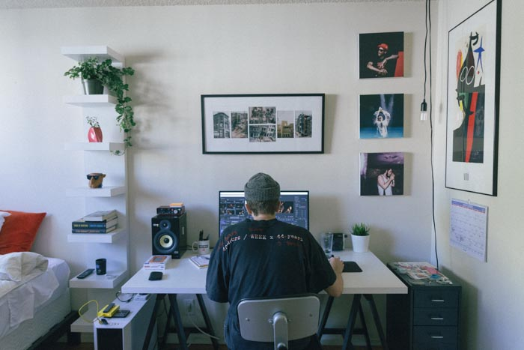
[ExpertPhotography is supported by readers. Product links on ExpertPhotography are referral links. If you use one of these and buy something, we make a little bit of money. Need more info? See how it all works here.]
Contents
On a Budget – GIMP 3
Need Smartphone Version – Photoshop 3
Using a Laptop or Space Conscious – GIMP 3
Business Expense – Photoshop 4
Fast and Stable – GIMP 4
For All Other Things, Apart From Photographing – Photoshop 5
Customisable and Flexible Interface – GIMP 5
Plays Well With Others – Photoshop 6
Cuts Out All the Unessecery Stuff – GIMP 6
Need to Use CYMK – Photoshop 6
Open-Source and therefore, Modifiable – GIMP 6
Non-destructive – Photoshop 7
Superior Batch Processing – GIMP 7
Constant Development – Photoshop 7
Free Upgrades – GIMP 8
More Powerful Tools – Photoshop 9
Portable – GIMP 9
Handle Raw Images – Photoshop 9
Open, Edit and Save PSD Files – Both 9
Conclusion 10

On a Budget – GIMP
Photoshop, like all Adobe products used to be very expensive. The only way to use the program was to buy a one-time licensing fee of upwards of $700. Now, Creative Cloud has taken over, allowing you to use their products at a fee of $10+ a month.
However, GIMP is a free editing software. No licensing fees, monthly or ever. Even the updates are fee-less. This really makes a difference for those on a budget, or, those who are yet to see any financial returns on their photography.
GIMP is the better choice if your budget is stretched thin enough to miss that Creative Cloud monthly-fee.

Need Smartphone Version – Photoshop
If you need a mobile or smartphone version, then Photoshop is your answer. With Adobe Photoshop Express, you can edit your images on the move. GIMP has yet to offer a service like this, and, is doubtful they will do in near future.
With more and more of us working remotely, a laptop might not be a viable option. Especially if you are using a product such as the GNAR Box.

Using a Laptop or Space Conscious – GIMP
Many of us photographers are using older laptops and desktop machines to edit our images. By no means is this a problem, until you try to download a huge program like Photoshop.
Not only does it take up a lot of space, it also needs a large buffer space, allowing you to edit your images.
If you are conscious about space, or the speed of your workflow, then Photoshop may not be for you.
GIMP is 20x smaller, which means it is faster to download, setup, and doesn’t eat away at precious space, both physical (on your hard drive) and RAM.
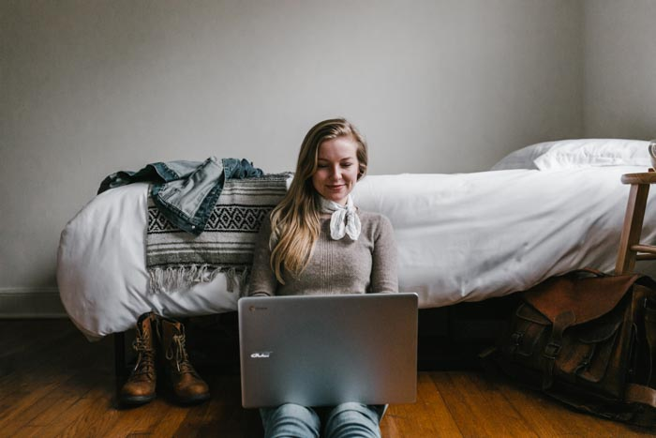

Business Expense – Photoshop
GIMP is a free editing software package, which is great if you need to pick up the bills. However, some photographers and creatives use Adobe Photoshop as their boss or company picks up the tab. Even from working as a freelancer you can claim the money back as a business expense.
This is great if you need a more powerful software than GIMP, but can’t afford to be out of pocket each month.

Fast and Stable – GIMP
Photoshop wasn’t built with only digital photographs in mind. It covers all aspects of designing, illustrating and many other disciplines, this means that Photoshop has many tools that you will never use.
This takes space and makes the learning process much more confusing.
GIMP, on the other hand, built with digital photography in mind. So, you cut out all the unnecessary tools from the mix. It is not only faster; you have less chance of doing something that you have no idea how to fix.

For All Other Things, Apart from Photographing – Photoshop
GIMP offers some really cool features, such as being able to create the Droste Effect, or even turning your images into tiny worlds. It is invaluable for some creative projects. However, there will be times when you want to use your photography for many other things.
For example, food photography may require using Layers to add text or other graphics into the mix. Photoshop allows this, whereas GIMP falls short.
Although some video game artwork used GIMP, you are hard pushed to find features that GIMP covers that Photoshop doesn’t.

Customisable and Flexible Interface – GIMP
GIMP not only works on UNIX systems, itself is fully customisable. You are free to move and push away tools and areas you will not require. This is great for keeping only the things you need, speeding up your workflow process.
It is as flexible as you need it, also allowing you to re-create keyboard shortcuts as you see fit.
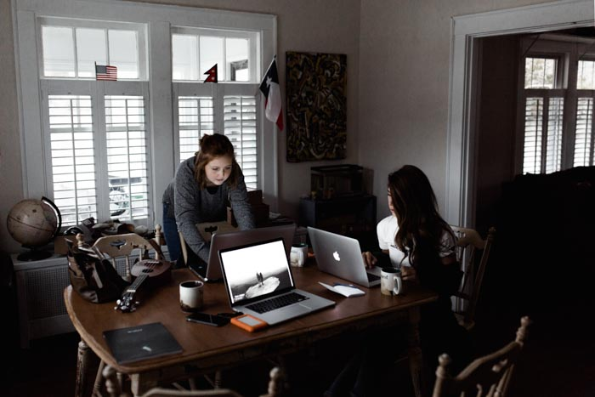

Plays Well with Others – Photoshop
Photoshop, just like all Adobe programs, play well with others. By others, I do mean other Adobe programs. With a click of a button, you can send your image back and forth between Lightroom and Photoshop, within the programs themselves.
They smartly keep track of all editing and file resizing across all platforms.
GIMP will open PSD files, but you need to export and save the images onto your desktop and reopen into the software. This is where editing the images and saving can be a problem. Especially as the editing processes are destructive (not keeping the original file separate).

Cuts Out All the Unnecessary Stuff – GIMP
Like I mentioned before, there are many things that GIMP doesn’t have that Photoshop does, simply because they are not needed. This saves space and makes your workflow much faster.
It is sleek and concise, meaning you can edit your images faster, getting through them faster.

Need to Use CYMK – Photoshop
If you need to use other colour modes, Photoshop is your guy. GIMP will only process using RGB. There is a way to convert your images to CYMK, but it requires a separate plugin. The RGB colour profile is great for the web, so most of your work will be safe.
When it comes to printing your images, CYMK is absolute must. Printers are still based around the fact that different plates for Cyan, Yellow, Magenta and blacK were needed to create a colour image.
They provide the colours on your printer, closest to what you see on your screen.

Open-Source and therefore, Modifiable – GIMP
GIMP is an open-source program. It means that you can if you know how to change the operating code. It isn’t illegal, it is strongly encouraged, and was set-up for this purpose.
For example. The useful “Content Aware Fill” feature in Photoshop isn’t actually part of GIMP as standard. However, with the use of a plug-in, you can download ‘The Heal Selection plugin’ (aka smart remove) and use it as if you were on Photoshop.
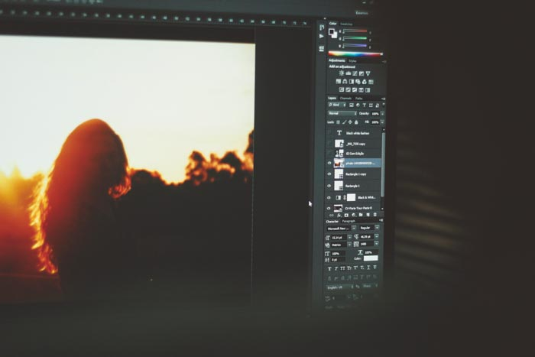

Non-destructive – Photoshop
Destructive editing means that you write over the original. This stops you from reverting back if you accidentally save over it. This is undoubtedly one of the best reasons to use Lightroom. Here, the original is saved, and any exports are separate files.
Photoshop can use Lightroom easily as a library, and therefore saving the original in case of accidents. It is also less destructive than GIMP, but you need to follow a few techniques to ensure this.

Superior Batch Processing – GIMP
Photoshop can batch process images, but it takes a little getting used to. You could set everything up using actions, wait an hour and find out something wasn’t set up correctly.
GIMP is superior in batch processing images. It will let you do repeatable actions to large groups of images. This alone is a great reason to use GIMP vs Photoshop.

Constant Development – Photoshop
The team behind Photoshop is always tweaking and upgrading the program. Now, during the time of the Creative Cloud, things are no different. All you need to do is download and install when they become available.
On top of this, Adobe offers great customer service. Photoshop, just like the rest of Adobe, has a huge team dedicated to giving you the best product possible.
GIMP offers upgrades every few months, but never as big or sufficient as the Photoshop updates.

Free Upgrades – GIMP
GIMP offers free upgrades on its already free software package. This ensures you will never be out of pocket, keeping the program free to use. Photoshop upgrades are also free, but you are paying for that service.
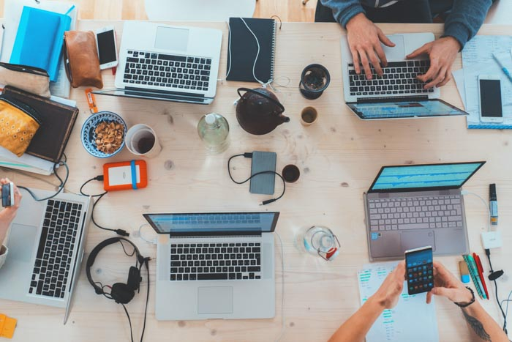

More Powerful Tools – Photoshop
Both programs have great tools, helping you edit your images properly and efficiently. The tools in Photoshop are much more powerful than the equivalent tools in GIMP. Bigger software, stronger processing tools.
Both programs use curves, levels and masks, but real pixel manipulation is stronger in Photoshop.
For example, Photoshop has four separate healing tools. Each of these come with an array of controls that lets you determine how they operate. GIMP has one healing tool, allowing you to remove the odd spot. For stronger applications, it just isn’t enough

Portable – GIMP
GIMP, as it is a small program, is portable. The whole program can sit on a pen drive and taken with you anywhere. A different laptop or desktop machine can be your temporary editing machine, as you have your software with you.
Perfect for saving space in your luggage when travelling.

Handle Raw Images – Photoshop
One of the best benefits of Photoshop is they can convert RAW images. Camera RAW comes as standard, so as soon as you open your RAW file, the RAW editor pops up. You can use RAW images in GIMP, but through a separate plug-in. This adds time and confusion into the mix.

Open, Edit and Save PSD Files – Both
There are many areas where GIMP and Photoshop overlap. Accessing PSD files, the native Photoshop files, can be done using both programs. This is perfect for all those photographers who used Photoshop in the past.
You may have stopped using Photoshop, but your PSD images live on. GIMP allows you to open, edit and save those files.
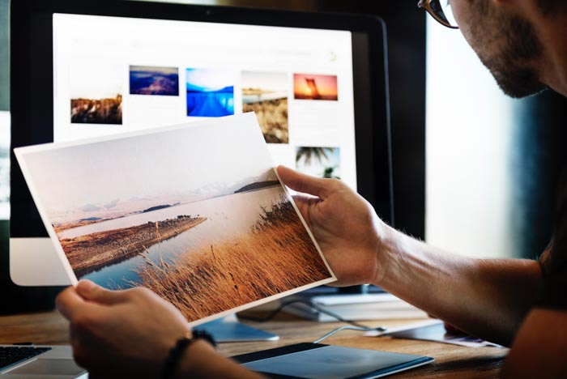

Conclusion
So, what’s our GIMP vs Photoshop conclusion? Both programs offer basically the same things. The tools that are not immediately apparent or available on GIMP are possible through Plugins or changing the core code.
Photoshop utilises stronger tools and offers a much stronger pixel manipulation than GIMP. Yet, if it isn’t something you need, then Photoshop is a moot program.
The one area I believe it comes down to is the price. Those who can afford it are more likely to go with Photoshop. $10 a month isn’t much if you use the program every day.
If you decide you aren’t going to use the program for a few months, you can even stop your subscription, re-started on a later date.
GIMP is free, with constant free updates. It might be more than enough if you aren’t heavily processing your images. Plus, if you are just getting started, GIMP offers a great ‘trial’ period to see if Photography and photographic editing are for you.
GIMP will continue to grow, but the team isn’t nearly as big as the one at Adobe. This is what you get for a paid service. The best thing about GIMP is that many programmers and photographer offer that service for you.
They will create and tweak plugins for you to use, replicating Photoshop at no cost.
PIN IT!  Save this article to your Pinterest profile to access it later! | 